**Title** Spatiotemporal patterns of invasive Devilweed *Sargassum horneri* in beach-cast seaweed wrack on San Nicolas Island, California

Ric DeSantiago1,2,3,…. and Jeremy D. Long1,2

1 Department of Biology, San Diego State University, San Diego, CA 98182 USA

2 Coastal and Marine Institute, San Diego State University, San Diego, CA 92106 USA

3 Department of Environmental Science and Policy, University of California, Davis, CA 95616 USA

**Abstract**

**Intro**

Introduction

Habitat subsidies can strongly shape the structure and function of recipient ecosystems (Polis and Hurd 1996, Menge et al. 1997, 2003, Nakano et al. 1999, Jefferies 2000, Palumbi 2003, Spiller et al. 2010). The quality and quantity of these subsidies will likely change as humans alter ecosystems through species introductions and range shifts associated with climate change. For example, lowered palatability of subsidies from replacement by less desirable invaders may 1) reduce the use of such subsidy by consumers, 2) shift consumption onto native species, or 3) disproportionately impact some consumers of such subsidies. However, life histories, reproductive strategy, and resistance to physical perturbations by introduced species may result in differing and sometimes complementary timing compared to native counterparts. Thus, understanding the seasonality and composition of resource pulses is needed to better understand if invasive species either reduce the quality and quantity of subsidies or serve as an additional subsidy.

Flow of subsidies between ecosystems are often in the form of seasonal inputs from a donor to recipient ecosystems, however, physical perturbations from climatic events (e.g., storms, El Niño / La Niña) may increase the timing and magnitude of some subsidies. These events may be brief and rare but account for a substantial proportion of all available resources in a system and can have important, sometimes persistent, effects on a wide range of communities (Ostfeld and Keesing 2000, Yang et al. 2008). However, we lack an understanding of how biological invasions in donor communities can change the supply and timing of organisms and materials to recipient habitats. Thus, monitoring of resource pulses in subsidized ecosystems may help us understand if invaders overalap or complement native resources.

Many beaches and rocky intertidal shores worldwide receive large inputs of wrack from offshore donor systems. It is well established that marine phytodetritus, dislodged seagrasses, and seaweeds washed ashore (collectively termed “wrack”) have significant ecological consequences to nearshore and shore habitats [(Bustamante et al., 1995, Duggins et al., 1989, Orr et al., 2005)](https://www.zotero.org/google-docs/?25X4OH). A combination of anthropogenic perturbations such as nutrient depositions, overharvesting, altered predator guilds, and climate change are altering natural ecosystems [(Falkowski et al., 2000, Greig et al., 2012, Worm et al., 2006)](https://www.zotero.org/google-docs/?WGalYb), thus, altering the quality and quantity of subsidies between ecosystems. Moreover, climate change is expected to increase the ranges of some species, and human activities increasingly move non-indigenous species beyond their normal range [(Rilov and Crooks, 2009, Ruiz et al., 1997)](https://www.zotero.org/google-docs/?ygqfQW). Thus, changes in wrack composition due to non-indigenous species introductions may have species-specific impacts on recipient native communities that depend on that subsidy [(Rodil et al., 2008)](https://www.zotero.org/google-docs/?FOSf5P)**.** This is especially important when recipient communities include sensitive and endangered species that rely on wrack. For example, the recent growing invasion of Devilweed (*Sargassum horneri*) in kelp forests [(Marks et al., 2015)](https://www.zotero.org/google-docs/?0ijcyF) may impact wrack-associated communities, including endangered Black abalone (*Haliotis cracherodii*) on rocky shores of Southern California and the Channel Islands .

**Methods**

We assessed the presence of Devilweed in the wrack on # sites on San Nicolas Island, California (SITES). To determine the relative contribution of Devilweed, we surveyed large wrack piles deposited on beaches and rocky shorelines measured the proportion of the pile surface area Devilweed represented (as in DeSantiago et al. 2024). This qualitative metric of Devilweed prevalence allowed us to quickly and instructively sample wrack piles at various sites along the coast. We selected all wrack piles (>1m length) we encountered along a haphazardly placed 50 m transect, identified the dominant seaweed species, and measured the surface area. We measured the depth at the center, the longest length, and width of the piles to calculate the surface area of a half ellipsoid using equation ######. For each Devilweed individual encountered on the surface of the pile, we measured its longest length and width to calculate the area using the equation for an ellipse (*A=πab*), where “a” and “b” are one half the length and width. For a single pile, we calculated the sum area of all Devilweed individuals and divided it by the surface area of the pile to estimate the proportion of wrack that consisted of Devilweed. Using this method, the relative contribution of Devilweed to wrack for a large pile could be estimated in minutes as opposed to hours (DeSantiago et al. 2024).

Because beached seaweeds are often dislodged by physical forces that fracture stipes and break down on the shore, we also quantified the presence of Kelp and Devilweed fragments on beaches. To do this, we haphazardly placed a 50m transect parallel with the water on the highest end of each beach, adjacent to the transects in the survey described above. We used a measuring wheel starting from three randomly selected points on the transect and counted every fragment of seaweed that intercepted the wheel on the way down to the waterline. The length of each fragment of Kelp and Devilweed was measured and identified.

At each site, we exhaustively searched for Devilweed for 30 minutes by one person or 15 minutes with two people. We conducted these surveys in areas adjacent to the surveys described above to avoid overlap. The length and width of all Devilweed stipes and fragments were measured and recorded.

**Data Analysis**

**Results**

Wrack piles are more consistent in September at all sites. The highest wrack area was in May at tender beach. Tender continues to have the highest input of wrack fragments than other sites throughout most of the year. Highest fragmented seaweed occurs in December. More occurrences of s horneri fragments occur at red eye and tender in September. Mean fragment size seem to be centered around 32mm – 64 mm occurrences of s. horneri only really showing up in September. More S. horneri per unit time found in March and may, some found in December but none in September.

**Figures**

**Total surface area of wrack piles larger (> 1m) by species by site per sampling trip**

**Total number of beached seaweed fragments found per 50m of beach by site per sampling trip** 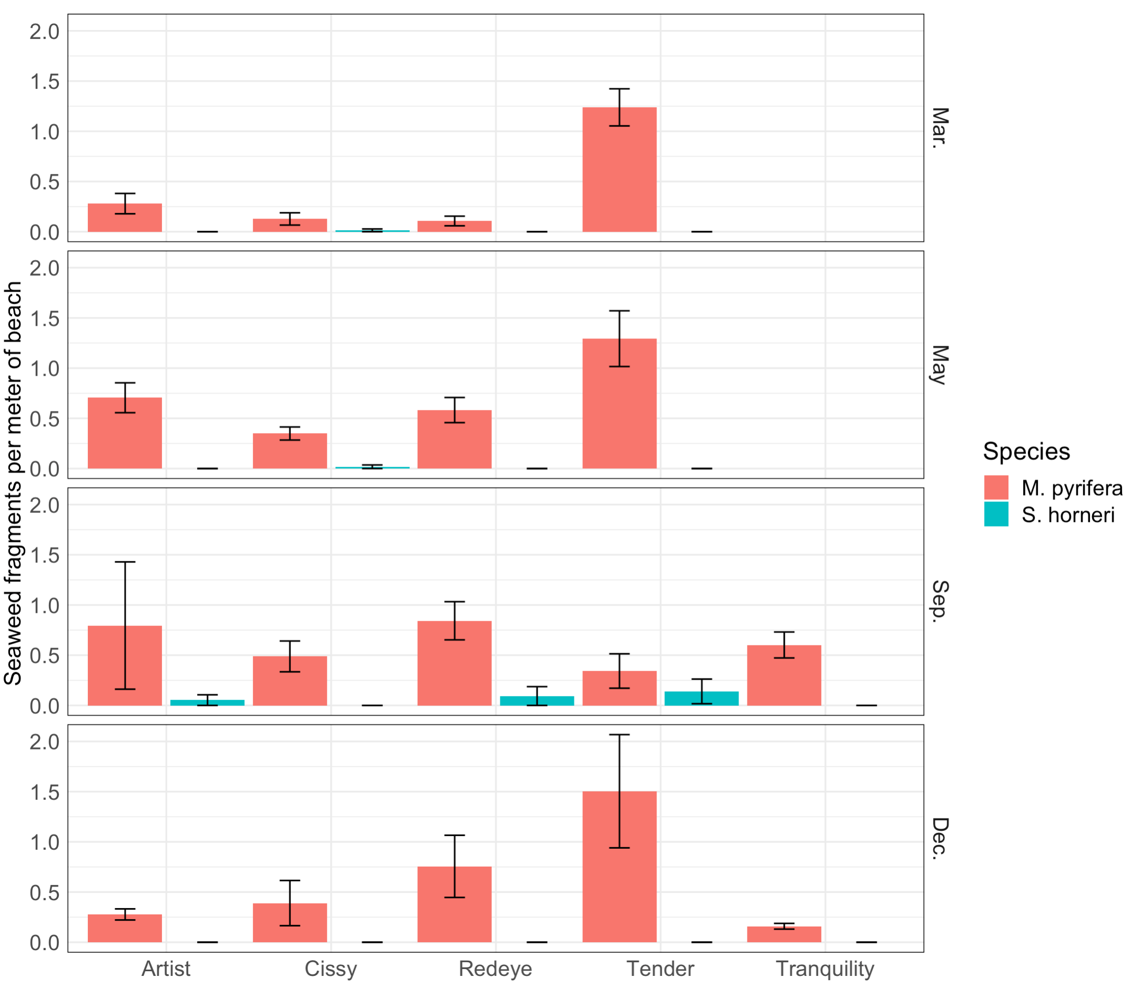

**Discussion**

**I k** **# Assuming your data frame is named 'horneri'**

**mean_percent <- mean(horneri$percent)**

**se_percent <- sd(horneri$percent) / sqrt(length(horneri$percent))**

**# Print the results**

**cat("Mean of 'percent':", mean_percent, "\n")**

**cat("Standard Error of 'percent':", se_percent, "\n")**